# Uploading the project

1. Upload ZIP file with code

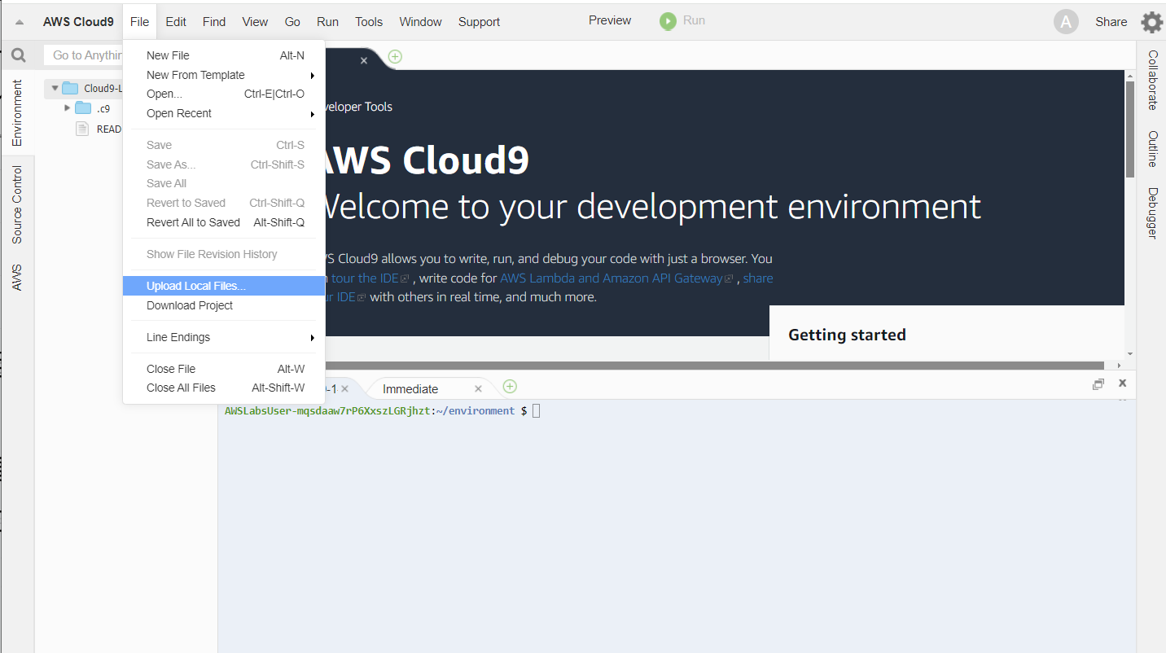

1. The ZIP file is now in your home directory

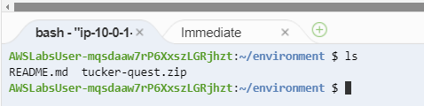

Feel free to move it elsewhere if you prefer

1. Unzip the ZIP file typing

$ unzip tucker-quest.zip

This will unpack the archive under a folder “tucker-quest”. Go into that directory. You should be able to see all the files in Cloud 9 now:

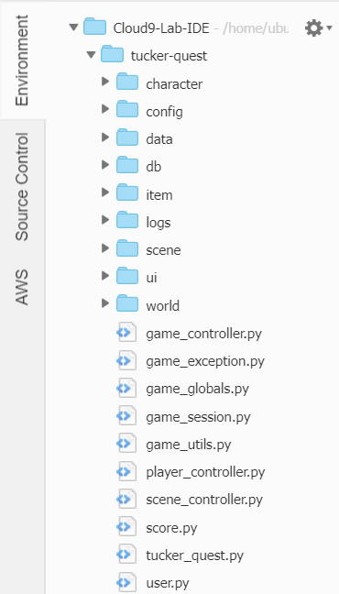

1. Cd into the tucker-quest directory

$ cd tucker-quest

1. Run the main program (you can also run it by opening the file and using the Cloud9 run option)

$ python tucker_quest.py

1. You should now be able to see the opening page

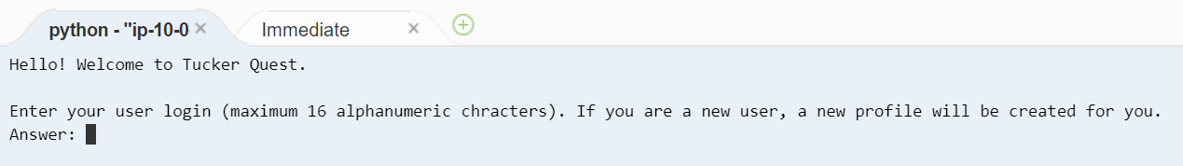

# Saving your project

I will be sharing an up to date version of the project every week. However, if you make any of your personal changes, make sure you download them and save them to your local computer, or you may lose them if the practice environment is taken down. Fortunately, that’s very quick and easy in Cloud9.

1. Right-click on the ***tucker-quest*** folder in Cloud9, and select the ***Download*** option

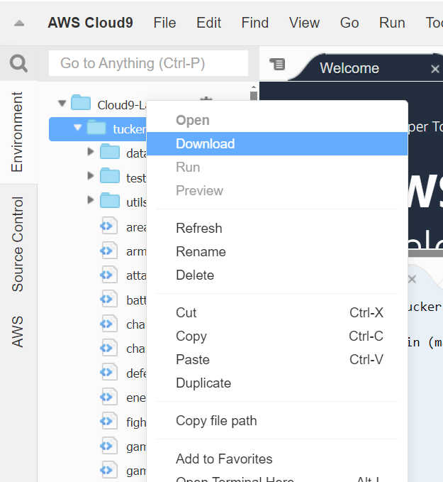

1. This will download a ***tucker-quest.zip*** file to whatever is your default browser download area.